 

UNIVERSITY ADMIT ELIGIBILITY PREDICTOR A PROJECT REPORT

***Submitted by***

|  |  |
| --- | --- |
| **VIGNESH KUMAR K** | **- 412519205155** |
| **SNEHA JAISWAL** | **- 412519205162** |
| **HARIHARAN SV** | **- 412519205043** |
| **NIVETHA K** | **-412519205097** |

***in partial fulfillment for the award of the degree***

***of***

# BACHELOR OF ENGINEERING

***in***

# INFORMATION TECHNOLOGY

**SRI SAI RAM ENGINEERING COLLEGE**

# (An Autonomous Institution; Affiliated to Anna University, Chennai -600 025) ANNA UNIVERSITY:: CHENNAI 600 025

**JULY 202**

**1.INTRODUCTION**

**1.1 PROJECT OVERVIEW**

In the current world scenario, just having a bachelor's degree is not enough. Most employers now require new employees to be highly qualified. Correspondingly, the requirements for a good university education are also higher. Many students prefer to continue their higher education. Admission to these universities requires some academic requirements. However, with so many different levels of colleges and universities, students are often left with the last-minute dilemma of whether or not their application will be accepted due to the lack of specific documentation stating their requirements. Developed after examining many leading machine learning algorithms, our AI models are the most accurate predictors of a student's admissions likelihood based on their current college-level grades and other academic background of their choice. To do. The purpose of this project is for users to enter their academic data and receive predictions regarding their likelihood of admission to their desired college level. The system will also implement a database so students can store data, review and edit as they progress, and their latest predictions will be saved in their profile. Aspects of web security other than password protection within the site are not part of this project. Students - Indian students will benefit most from this scheme. Administrators - Administrators should have access to all data stored in the application. The system is available to all users from anywhere as long as they have an internet connection. The administrator can access her website from anywhere with the correct credentials and internet access.

The system should answer students' questions competently and succinctly, and provide the most accurate analysis possible of their chances of getting into college. The system is based on a limited data set, which can affect the overall accuracy of predictions. Many other factors such as personal interviews also play a large role in the admission process, so the system cannot guarantee that our predictions are 100% guaranteed admission. Other factors, such as changes in colleges and university policies, may also affect your chances of admission in ways beyond the scope of this project.

**1.2 PURPOSE**

This is the project for a new web-based University Admit Eligibility Predictor. Predictor is an ML based application that asks for the users to input their academic transcripts data and calculates their chances of admission into the University Tier that they selected. It also provides an analysis of the data and shows how chances of admissions can depend on various factors. This document describes the scope, objectives and goals of the system. In addition to describing the non-functional requirements, this document models the functional requirements with use cases, interaction diagrams and class models. This document is intended to direct the design and implementation of the target system in an object-oriented language.

**2.LITERATURE SURVEY**

**2.1 EXISTING PROBLEM**

It’s almost admission season and I’ve couple of friends who are in panic mode waiting for a call from the universities they’ve applied at. This made me think — How can we predict whether a student will get an admit or not? What are the parameters for selection? Can it be mathematically expressed? All of these questions started popping up. This is the main existing problem.

**2.2 REFERENCES**

➤ <https://ieeexplore.ieee.org/document/9418279>

Abstract: Students regularly have difficulty finding a fitting institution to pursue higher studies based on their profile. There are some advisory administrations and online apps that recommend universities but they ask huge consultancy fees and online apps are not accurate. So, the aim of this research is to develop a model that predict the percentage of chances into the university accurately. References: MS Acharya, A Armaan and AS Antony, "A comparison of regression models for prediction of graduate admissions", 2019.

➤ <https://ieeexplore.ieee.org/document/9410717>

Abstract: Students applying for admissions to universities find it difficult to understand whether they have good chances of getting admission in a university or not. Keeping this in focus, we have used logistic regression techniques that have gained attention in software engineering field for its ability to be used for predictions. This is a novel work on a university admissions predictor using which students can evaluate their competitiveness for getting admission at a university.

➤ <https://ieeexplore.ieee.org/document/6416521>

Abstract: This paper presents a new college admission system using hybrid recommender based on data mining techniques and knowledge discovery rules, for tackling college admissions prediction problems. This is due to the huge numbers of students required to attend university colleges every year. The proposed HRSPCA system consists of two cascaded hybrid recommenders working together with the help of college predictor, for achieving high performance. References: G. Ganapathy, and K. Arunesh, "Models for Recommender Systems in Web Usage Mining Based on User Ratings" Proceedings of the World Congress on Engineering, Vol. I WCE 2011.

➤ <https://dl.acm.org/doi/10.1145/3388818.3393716>

Abstract: With the increase in the number of graduates who wish to pursue their education, it becomes more challenging to get admission to the students' dream university. Newly graduate students usually are not knowledgeable of the requirements and the procedures of the postgraduate admission and might spent a considerable amount of money to get advice from consultancy organizations to help them identify their admission chances. References: E. Roberts, "using machine learning and predictive modeling to assess admission policies and standards," 2013.

➤ <https://github.com/satwik2663/Machine-Learning-Graduate-Studuent-AdmissionPredictor>

Abstract: Today, there are many students who travel to USA to pursue higher education. It is necessary for the students to know what are their chances of getting an admit in the universities. Also, universities manually check and count the total number of applicants who could get an admit into university. These methods are slow and certainly not very consistent for students and universities to get an actual result. This method is also prone to human error and thus accounts for some inaccuracies. Since the frequency of students studying abroad has increased, there is a need to employ more efficient systems which handle the admission process accurately from both perspectives.

➤ <https://github.com/anjanatiha/University-Admission-Match-Predictor>

Abstract: 1. Analyzed university admission statistics. 2. Developed tools for matching university (in percentile) using CGPA, GRE (Verbal, Quantitative, Analytical Writing) scores.

➤ <https://github.com/karanwadhwa/dd-admission-predictor>

Abstract: This system was originally developed only for Engineering College Admissions in Maharashtra, India but can essentially be adapted for other streams too. The purpose of it is to build a system to predict the user’s chances for getting into a certain college.

**2.3 PROBLEM STATEMENT DEFINITION**

This is a requirement specification for a new college admissions eligibility prediction based on data science. This is an AI-based application that prompts users to enter their transcript details and calculates their chances of admission to their chosen college level. It also provides an analysis of the data and shows how the likelihood of admission depends on various factors. This document describes the scope, goals, and objectives of the system. In addition to explaining non-functional requirements.

In the current world scenario, just having a bachelor's degree is not enough. Most employers now require new employees to be highly qualified. Correspondingly, the requirements for a good university education are also higher. Many students prefer to continue their higher education. Admission to these universities requires some academic requirements. However, with so many different levels of colleges and universities, students are often left with the last-minute dilemma of whether or not their application will be accepted due to the lack of specific documentation stating their requirements. Developed after examining many leading machine learning algorithms, our AI models are the most accurate predictors of a student's admissions likelihood based on their current college-level grades and other academic background of their choice. To do. The purpose of this project is for users to enter their academic data and receive predictions regarding their likelihood of admission to their desired college level. The system will also implement a database so students can store data, review and edit as they progress, and their latest predictions will be saved in their profile. Aspects of web security other than password protection within the site are not part of this project.

Students - Indian students will benefit most from this scheme.

Administrators - Administrators should have access to all data stored in the application. The system is available to all users from anywhere as long as they have an internet connection. The administrator can access her website from anywhere with the correct credentials and internet access.

Overview of Document: The system should answer students' questions competently and succinctly, and provide the most accurate analysis possible of their chances of getting into college. The system is based on a limited data set, which can affect the overall accuracy of predictions. Many other factors such as personal interviews also play a large role in the admission process, so the system cannot guarantee that our predictions are 100% guaranteed admission. Other factors, such as changes in colleges and university policies, may also affect your chances of admission in ways beyond the scope of this project.

**3. IDEATION & PROPOSED SOLUTION**

**3.1 Empathy Map Canvas**

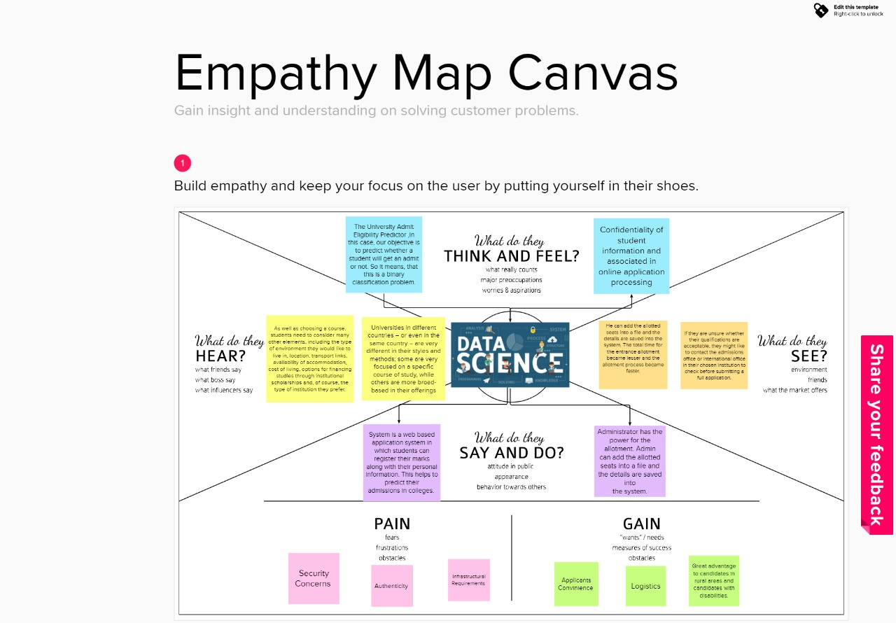

**3.2 Ideation & Brainstorming**

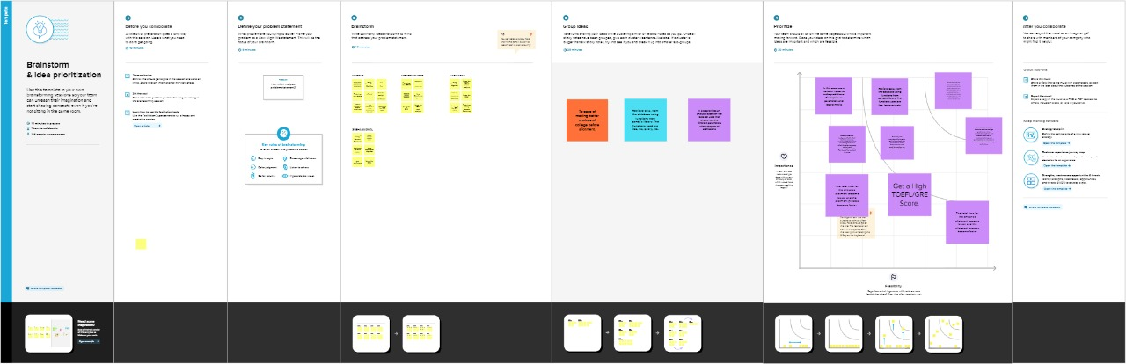

**3.3 Proposed Solution :**

|  |  |  |
| --- | --- | --- |
| **S.No** | **Parameter** | **Description** |
| 1. | Problem Statement (Problem to be solved) | How might we design an eligibility predictor for students which provides them with their chances of getting admitted into different universities based on their scores and other important criteria. |
| 2. | Idea / Solution description | The aim of this project is to help students in shortlisting universities with their profiles. The predicted output gives them a fair idea about their admission chances in a particular university. This analysis should also help students who are currently preparing or will be preparing to get a better idea regarding the admission process.  A model is developed which analyses the data provided by the user and evaluates it in accordance with the algorithm developed to predict the eligibility of the user  for the specified university. |
| 3. | Novelty / Uniqueness | We aim to design the model in such a way that it takes certain non-academic factors which influence the admission process into consideration as well. This further enhances the accuracy of the predictor. This  attribute is not considered in most predictors available in the market. |
| 4. | Social Impact / Customer Satisfaction | This predictor would provide a clarity to passed out students who might be confused regarding their future  with respect to university admissions. The students can apply to universities based on their eligibility chances. |
| 5. | Business Model (Revenue Model) | Such predictors have a huge demand in the market since students who complete their schooling are always in  need of tools like this to plan out their university admissions. |
| 6. | Scalability of the Solution | The scope of this predictor is very wide as a large number of universities could be brought within the range of this predictor depending on the requirements of the user.  Hence, this solution is largely scalable in nature. |

**3.4 Problem Solution fit:**

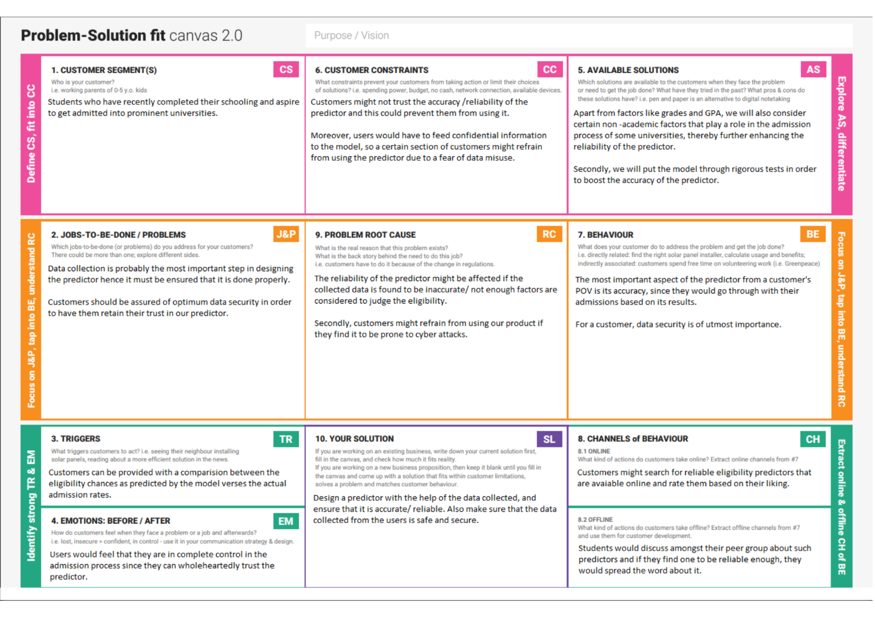

**4. REQUIREMENT ANALYSIS**

**4.1 Functional requirement**

Following are the functional requirements of the proposed solution.

|  |  |  |
| --- | --- | --- |
| **FR No.** | **Functional Requirement (Epic)** | **Sub Requirement (Story / Sub-Task)** |
| FR-1 | User Registration | * Registration through Form * Registration through Gmail * Registration through LinkedIn |
| FR-2 | User Confirmation | * Confirmation via Email * Confirmation via OTP |
| FR-3 | User Requirements | * All the needed files are been asked to feed in the website. * Based on the uploads, the system would collect all the necessary information. * The information includes the list of all   the possible universities and streams. |
| FR-4 | User Details | Has to feed some documents   * Score Sheets * Letter of Recommendation (LOR) * Statement of Purpose (SOP) * Curriculum Vitae (CV) |

**4.2 Non-Functional requirements**

Following are the non-functional requirements of the proposed solution.

|  |  |  |
| --- | --- | --- |
| **FR No.** | **Non-Functional Requirement** | **Description** |
| NFR-1 | **Usability** | * Our website is very user friendly. * There is no need for any technical skill in order to access our website. * The page would not take a lot of time to load the content. |
| NFR-2 | **Security** | * The user who is having the valid credentials can able to access our site. |
|  |  | * Under any error, the system should be able to come back to regular operation in   under an hour. |
| NFR-3 | **Reliability** | * Our website is more reliable. * Since nobody can able to see the data fed by the user. |
| NFR-4 | **Performance** | * User can able to access in our website with internet connection. * Traffics can be handled effectively. |
| NFR-5 | **Availability** | * Fast and efficient. * Students can access our website from any of * the available browser. |

**5. PROJECT DESIGN**

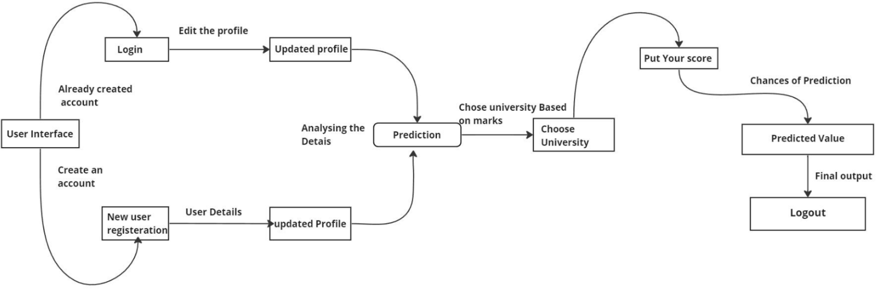 **5.1 Data Flow Diagrams**

**5.2 Solution & Technical Architecture**



**5.3 User Stories**

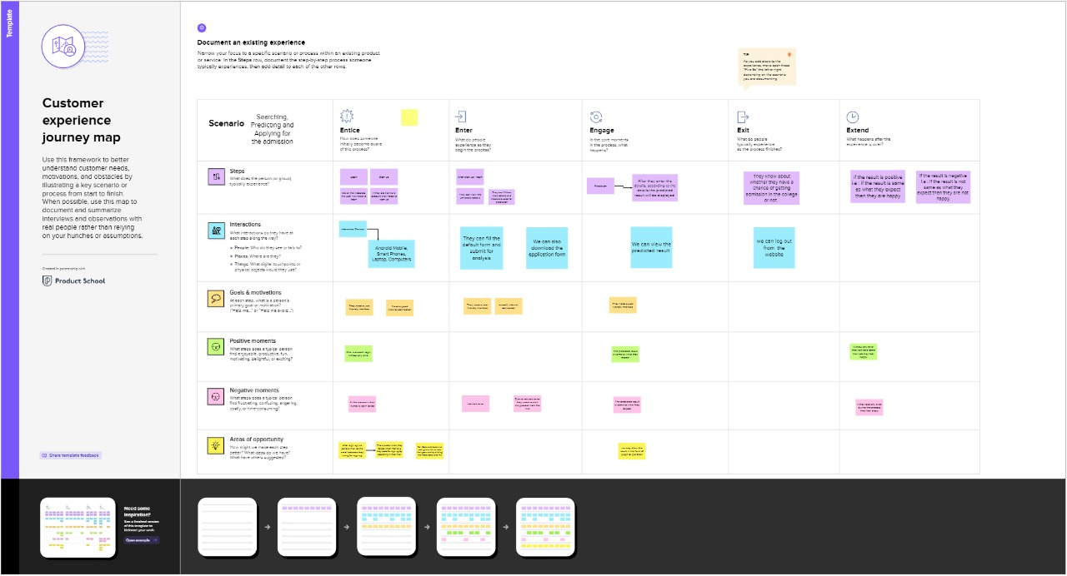

**6. PROJECT PLANNING & SCHEDULING**

**6.1 Sprint Planning & Estimation**

|  |  |  |  |  |  |  |
| --- | --- | --- | --- | --- | --- | --- |
| **Sprint** | **Total Story Points** | **Duration** | **Sprint Start Date** | **Sprint End Date (Planned)** | **Story Points Completed (as on**  **Planned End Date)** | **Sprint Release Date (Actual)** |
| Sprint-1 | 20 | 7 Days | 31 Oct 2022 | 05 Nov 2022 | 20 | 05 Nov 2022 |
| Sprint-2 | 20 | 4 Days | 06 Oct 2022 | 08 Nov 2022 | 20 | 09 Nov 2022 |
| Sprint-3 | 20 | 4 Days | 09 Nov 2022 | 11 Nov 2022 | 20 | 11 Nov 2022 |
| Sprint-4 | 20 | 4 Days | 12 Nov 2022 | 14 Nov 2022 | 20 | 15 Nov 2022 |

**6.2 Sprint Delivery Schedule**

|  |  |  |  |  |  |  |
| --- | --- | --- | --- | --- | --- | --- |
| **Sprint** | **Functional Requireme**  **nt (Epic)** | **User Story**  **Number** | **User Story / Task** | **Story Points** | **Priority** | **Team Members** |
| Sprint-1 | Registration | USN-1 | As a user, you can register in the application by entering your email address, password,  and confirming the password | 2 | High | Nivetha K |
| Sprint-1 |  | USN-2 | As a user, you will receive a confirmation email after registering in  the application | 1 | High | Vignesh Kumar K |
| Sprint-2 |  | USN-3 | As a user, you can register in the  application via Facebook | 2 | Low | Hariharan SV |
| Sprint-1 |  | USN-4 | As a user, you can register in the  application via Gmail | 2 | Medium | Sneha Jaiswal |
| Sprint-1 | Login | USN-5 | As a user, you can login to the application by  entering your email and password | 1 | High | Vignesh Kumar K |

**Velocity:**

Imagine we have a 10-day sprint duration, and the velocity of the team is 20 (points per sprint). Let’s calculate the team’s average velocity (AV) per iteration unit (story points per day)

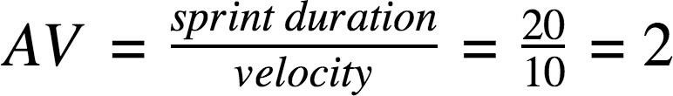

**Burndown Chart:**

A burn down chart is a graphical representation of work left to do versus time. It is often used in agile [software development](https://www.visual-paradigm.com/scrum/what-is-agile-software-development/) methodologies such as [Scrum](https://www.visual-paradigm.com/scrum/scrum-in-3-minutes/). However, burn down charts can be applied to any project containing measurable progress over time.

**7. CODING & SOLUTIONING (Explain the features added in the project along with code)**

**7.1 Feature 1**

<!DOCTYPE html>

<html lang="en">

<head>

    <meta charset="UTF-8">

    <meta http-equiv="X-UA-Compatible" content="IE=edge">

    <meta name="viewport" content="width=device-width, initial-scale=1.0">

    <title>

        UNIVERSITY ADMISSION PREDICTOR

    </title>

    <link rel="stylesheet" href="/static/styles/style.css">

</head>

<body>

    <h1 style="color: aliceblue; background-color: black;">UNIVERSITY ADMISSION PREDICTOR</h1>

    <form id="form" action="/prediction" method="post">

        <div class="form-control">

            <label for="name" id="label-name">ENTER GRE SCORE:</label>

            <input type="text" name="grescore" id="grescore" placeholder="90" />

        </div>

        <div class="form-control">

            <label for="email" id="label-email">ENTER TOEFL SCORE:</label>

            <input type="text" name="toeflscore" id="toeflscore" placeholder="90" />

        </div>

        <div class="form-control">

            <label for="university">SELECT UNIVERSITY RATING:</label>

            <select name="university" id="university">

                <option value="select university no">SELECT UNIVERSITY NO</option>

                <option value="1">1</option>

                <option value="2">2</option>

                <option value="3">3</option>

                <option value="4">4</option>

                <option value="5">5</option>

            </select>

        </div>

        <div class="form-control">

            <label for="name" id="label-name">ENTER SOP:</label>

            <input type="text" name="sop" id="sop" placeholder="1" />

        </div>

        <div class="form-control">

            <label for="name" id="label-name">ENTER LOR:</label>

            <input type="text" name="lor" id="lor" placeholder="3" />

        </div>

        <div class="form-control">

            <label for="name" id="label-name">ENTER CGPA:</label>

            <input type="text" name="cgpa" id="cgpa" placeholder="8.9" />

        </div>

        <div class="form-control">

            <label >RESEARCH:</label>

            <label for="recommed-1">

                <input type="radio" id="recommed-1" name="recommed-1">RESEARCH</input>

            </label>

            <label for="recommed-2">

                <input type="radio" id="recommed-2" name="recommed-1">NO RESEARCH</input>

            </label>

        </div>

        <button type="submit" value="submit" href="#"> PREDICT </button>

    </form>

</body>

</html>

**7.2 Feature 2**

**Eligible**

<!DOCTYPE html>

<html lang="en">

<head>

    <meta charset="UTF-8">

    <meta http-equiv="X-UA-Compatible" content="IE=edge">

    <meta name="viewport" content="width=device-width, initial-scale=1.0">

    <title>Document</title>

    <link rel="stylesheet" href="https://stackpath.bootstrapcdn.com/bootstrap/4.5.0/css/bootstrap.min.css">

<script src="https://code.jquery.com/jquery-3.5.1.min.js"></script>

<script src="https://stackpath.bootstrapcdn.com/bootstrap/4.5.0/js/bootstrap.min.js"></script>

</head>

<body>

    <img style="margin-top:100px;height:220px; width:220px" src="/static/bg3.jpg" class="img-responsive center-block d-block mx-auto" alt="Sample Image">

    <center><p style="font-size: 50px;">HURRAY!! YOU ARE ELIGIBLE FOR THIS UNIVERSITY</p></center>

</body>

</html>

**Not Eligible**

<!DOCTYPE html>

<html lang="en">

<head>

    <meta charset="UTF-8">

    <meta http-equiv="X-UA-Compatible" content="IE=edge">

    <meta name="viewport" content="width=device-width, initial-scale=1.0">

    <title>Document</title>

    <link rel="stylesheet" href="https://stackpath.bootstrapcdn.com/bootstrap/4.5.0/css/bootstrap.min.css">

<script src="https://code.jquery.com/jquery-3.5.1.min.js"></script>

<script src="https://stackpath.bootstrapcdn.com/bootstrap/4.5.0/js/bootstrap.min.js"></script>

</head>

<body>

    <img style="margin-top:100px;height:220px; width:220px" src="/static/bg2.png" class="img-responsive center-block d-block mx-auto" alt="Sample Image">

    <center><p style="font-size: 50px;">SORRY!! YOU ARE NOT ELIGIBLE FOR THIS UNIVERSITY</p></center>

</body>

</html>

**7.3 Database schema**

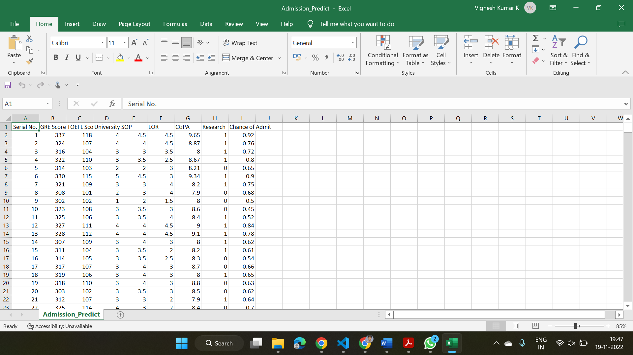

**8. TESTING**

**8.1 Test Cases**

**Test Case Analysis**

|  |  |  |  |  |
| --- | --- | --- | --- | --- |
| **Section** | **Total Cases** | **Not Tested** | **Fail** | **Pass** |
| Print Engine | 7 | 0 | 0 | 7 |
| Client Application | 51 | 0 | 0 | 51 |
| Security | 2 | 0 | 0 | 2 |
| Outsource Shipping | 3 | 0 | 0 | 3 |
| Exception Reporting | 9 | 0 | 0 | 9 |
| Final Report Output | 4 | 0 | 0 | 4 |
| Version Control | 2 | 0 | 0 | 2 |

**8.2 User Acceptance Testing**

**Purpose of Document**

The purpose of this document is to briefly explain the test coverage and open issues of the University Admit Eligibility Predictor project at the time of the release to User Acceptance Testing (UAT).

**Defect Analysis**

|  |  |  |  |  |  |
| --- | --- | --- | --- | --- | --- |
| **Resolution** | **Severity 1** | **Severity 2** | **Severity 3** | **Severity 4** | **Subtotal** |
| By Design | 10 | 4 | 2 | 3 | 19 |
| Duplicate | 0 | 0 | 0 | 0 | 0 |
| External | 2 | 3 | 0 | 1 | 6 |
| Fixed | 11 | 2 | 4 | 20 | 37 |
| Not Reproduced | 0 | 0 | 0 | 0 | 0 |
| Skipped | 0 | 0 | 1 | 1 | 2 |
| Won't Fix | 0 | 0 | 0 | 0 | 0 |
| Totals | 24 | 14 | 13 | 26 | 64 |

**9. RESULTS**

**9.1 Performance Metrics**



**10. ADVANTAGES & DISADVANTAGES**

1. **10.1 Advantages**
2. It helps student for making decision for choosing a right college.
3. Here the chance of occurrence of error is less when compared with the existing system.
4. It is fast, efficient and reliable.

**10.2 Disadvantages:**

1. Required active internet connection.
2. System will provide inaccurate results if data entered incorrectly.

**11. CONCLUSION**

This system ,being the first we have created in Python using ML algorithms and other front end languages such as html, css, java script , has proven more difficult than originally imagined. While it may sound simple to fill out a few forms and process the information, much more is involved in the selection of applicants than this. Every time progress was made and features were added, ideas for additional features or methods to improve the usability of the system made themselves apparent. Furthermore, adding one feature meant that another required feature was now possible, and balancing completing these required features with the ideas for improvement as well as remembering everything that had to be done was a project in itself. Debugging can sometimes be a relatively straight forward process, or rather rather finding out what you must debug can be. Since so many parts of the admissions system are integrated into one another, if an error occurs on one page, it may be a display error, for example; it may be the information is not correctly read from the database; or even that the information is not correctly stored in the database initially, and all three must be checked on each occasion. This slows down the process and can be frustrating if the apparent cause of a problem is not obvious at first. Language used must be simple and easy to understand and compatibility is paramount. If this system were not designed as an entirely web based application, it would not have been possible to recreate its current state of portability. Overall, the system performs well,and while it does not include all of the features that may have been desired, it lives up to initial expectations. The majority of features that are included work flawlessly and the errors that do exist are minor or graphical.

**12. FUTURE SCOPE**

The future scope of this project is very broad. Few of them are:

● This can be accessed anytime anywhere, since it is a web application provided only an internet connection.

● The user had not need to travel a long distance for the admission and his/her time is also saved as a result of this automated system.

**13. APPENDIX**

**Source Code**

**import** numpy **as** np

**import** pandas **as** pd

**import** matplotlib.pyplot **as** plt

### 2. Reading the dataset.

In [2]:

admission **=** pd**.**read_csv("dataset/Admission_Predict.csv") *# readin the dataset*

In [3]:

admission**.**head() *# to see the top five records of the data sets*

Out[3]:

|  | **Serial No.** | **GRE Score** | **TOEFL Score** | **University Rating** | **SOP** | **LOR** | **CGPA** | **Research** | **Chance of Admit** |
| --- | --- | --- | --- | --- | --- | --- | --- | --- | --- |
| **0** | 1 | 337 | 118 | 4 | 4.5 | 4.5 | 9.65 | 1 | 0.92 |
| **1** | 2 | 324 | 107 | 4 | 4.0 | 4.5 | 8.87 | 1 | 0.76 |
| **2** | 3 | 316 | 104 | 3 | 3.0 | 3.5 | 8.00 | 1 | 0.72 |
| **3** | 4 | 322 | 110 | 3 | 3.5 | 2.5 | 8.67 | 1 | 0.80 |
| **4** | 5 | 314 | 103 | 2 | 2.0 | 3.0 | 8.21 | 0 | 0.65 |

In [4]:

admission**.**shape *# to see what is the shape of data_set our data set has 400 records and 9 fields*

Out[4]:

(400, 9)

In [5]:

admission**.**columns *#to see the name of the fields*

Out[5]:

Index(['Serial No.', 'GRE Score', 'TOEFL Score', 'University Rating', 'SOP',

'LOR ', 'CGPA', 'Research', 'Chance of Admit '],

dtype='object')

In [6]:

admission**.**describe() *# to see the mathematical values of the data sets i.e mean,standar_deviation ,minimum_value,maximum_value,counts etc.*

Out[6]:

|  | **Serial No.** | **GRE Score** | **TOEFL Score** | **University Rating** | **SOP** | **LOR** | **CGPA** | **Research** | **Chance of Admit** |
| --- | --- | --- | --- | --- | --- | --- | --- | --- | --- |
| **count** | 400.000000 | 400.000000 | 400.000000 | 400.000000 | 400.000000 | 400.000000 | 400.000000 | 400.000000 | 400.000000 |
| **mean** | 200.500000 | 316.807500 | 107.410000 | 3.087500 | 3.400000 | 3.452500 | 8.598925 | 0.547500 | 0.724350 |
| **std** | 115.614301 | 11.473646 | 6.069514 | 1.143728 | 1.006869 | 0.898478 | 0.596317 | 0.498362 | 0.142609 |
| **min** | 1.000000 | 290.000000 | 92.000000 | 1.000000 | 1.000000 | 1.000000 | 6.800000 | 0.000000 | 0.340000 |
| **25%** | 100.750000 | 308.000000 | 103.000000 | 2.000000 | 2.500000 | 3.000000 | 8.170000 | 0.000000 | 0.640000 |
| **50%** | 200.500000 | 317.000000 | 107.000000 | 3.000000 | 3.500000 | 3.500000 | 8.610000 | 1.000000 | 0.730000 |
| **75%** | 300.250000 | 325.000000 | 112.000000 | 4.000000 | 4.000000 | 4.000000 | 9.062500 | 1.000000 | 0.830000 |
| **max** | 400.000000 | 340.000000 | 120.000000 | 5.000000 | 5.000000 | 5.000000 | 9.920000 | 1.000000 | 0.970000 |

In [7]:

admission**.**info() *#to see the type of values in every fields i.e int ,float etc*

RangeIndex: 400 entries, 0 to 399

Data columns (total 9 columns):

# Column Non-Null Count Dtype

--- ------ -------------- -----

0 Serial No. 400 non-null int64

1 GRE Score 400 non-null int64

2 TOEFL Score 400 non-null int64

3 University Rating 400 non-null int64

4 SOP 400 non-null float64

5 LOR 400 non-null float64

6 CGPA 400 non-null float64

7 Research 400 non-null int64

8 Chance of Admit 400 non-null float64

dtypes: float64(4), int64(5)

memory usage: 28.2 KB

In [8]:

admission**.**isnull()**.**sum() *# to see that if dataset has any null_values or not*

Out[8]:

Serial No. 0

GRE Score 0

TOEFL Score 0

University Rating 0

SOP 0

LOR 0

CGPA 0

Research 0

Chance of Admit 0

dtype: int64

### 3. Finding the dependent and independent variable.

In [9]:

X**=**admission**.**drop(['Serial No.','Chance of Admit '],axis**=**1) *#input data_set*

X**.**shape

Out[9]:

(400, 7)

In [10]:

y**=**admission['Chance of Admit '] *#output labels*

y**.**shape

Out[10]:

(400,)

In [11]:

admission**.**sample(5)

Out[11]:

|  | **Serial No.** | **GRE Score** | **TOEFL Score** | **University Rating** | **SOP** | **LOR** | **CGPA** | **Research** | **Chance of Admit** |
| --- | --- | --- | --- | --- | --- | --- | --- | --- | --- |
| **347** | 348 | 299 | 94 | 1 | 1.0 | 1.0 | 7.34 | 0 | 0.42 |
| **397** | 398 | 330 | 116 | 4 | 5.0 | 4.5 | 9.45 | 1 | 0.91 |
| **207** | 208 | 310 | 102 | 3 | 3.5 | 4.0 | 8.02 | 1 | 0.66 |
| **327** | 328 | 295 | 101 | 2 | 2.5 | 2.0 | 7.86 | 0 | 0.69 |
| **224** | 225 | 305 | 105 | 2 | 3.0 | 2.0 | 8.23 | 0 | 0.67 |

### 4. Data Visualization

In [12]:

plt**.**scatter(admission['GRE Score'],admission['CGPA'])

plt**.**title('CGPA vs GRE Score')

plt**.**xlabel('GRE Score')

plt**.**ylabel('CGPA')

plt**.**show()

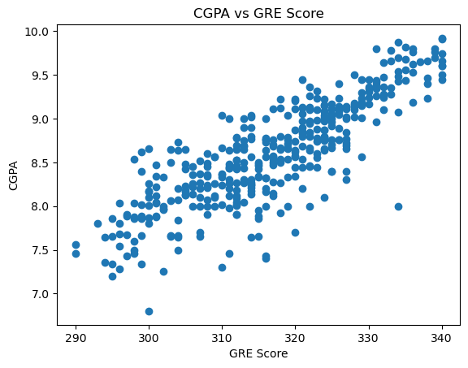

In [13]:

plt**.**scatter(admission['CGPA'],admission['SOP'])

plt**.**title('SOP for CGPA')

plt**.**xlabel('CGPA')

plt**.**ylabel('SOP')

plt**.**show()

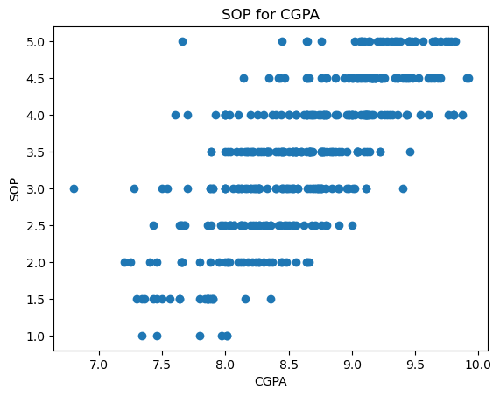

In [14]:

admission[admission**.**CGPA **>=** 8.5]**.**plot(kind**=**'scatter', x**=**'GRE Score', y**=**'TOEFL Score',color**=**"BLUE")

plt**.**xlabel("GRE Score")

plt**.**ylabel("TOEFL SCORE")

plt**.**title("CGPA>=8.5")

plt**.**grid(**True**)

plt**.**show()

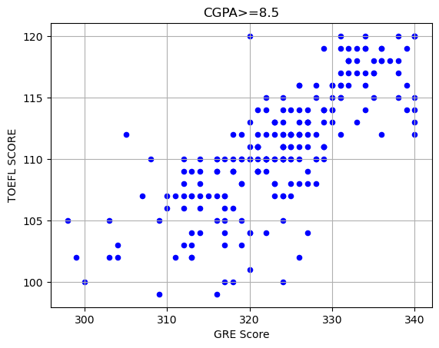

In [15]:

admission["GRE Score"]**.**plot(kind **=** 'hist',bins **=** 200,figsize **=** (6,6))

plt**.**title("GRE Scores")

plt**.**xlabel("GRE Score")

plt**.**ylabel("Frequency")

plt**.**show()

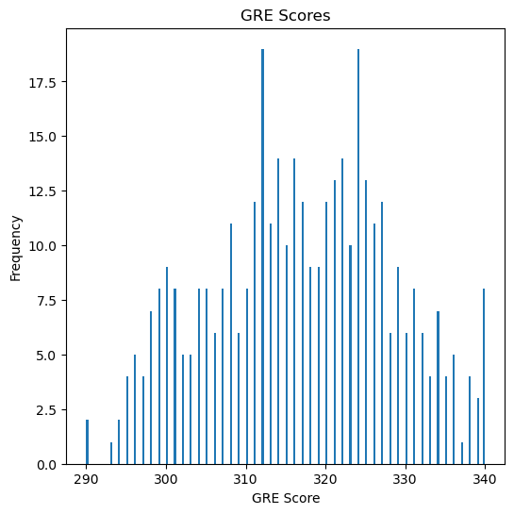

In [16]:

p **=** np**.**array([admission["TOEFL Score"]**.**min(),admission["TOEFL Score"]**.**mean(),admission["TOEFL Score"]**.**max()])

r **=** ["Worst","Average","Best"]

plt**.**bar(p,r)

plt**.**title("TOEFL Scores")

plt**.**xlabel("Level")

plt**.**ylabel("TOEFL Score")

plt**.**show()

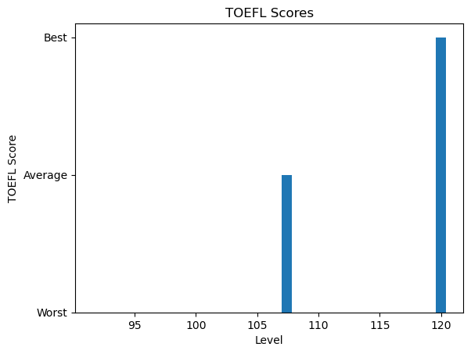

In [17]:

g **=** np**.**array([admission["GRE Score"]**.**min(),admission["GRE Score"]**.**mean(),admission["GRE Score"]**.**max()])

h **=** ["Worst","Average","Best"]

plt**.**bar(g,h)

plt**.**title("GRE Scores")

plt**.**xlabel("Level")

plt**.**ylabel("GRE Score")

plt**.**show()

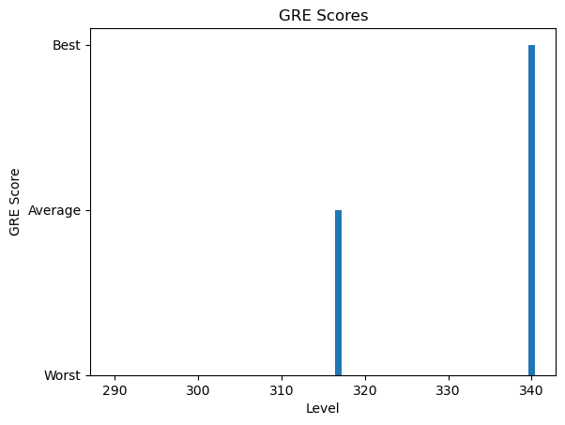

In [18]:

**import** seaborn **as** sns

plt**.**figure(figsize**=**(10, 10))

sns**.**heatmap(admission**.**corr(), annot**=True**, linewidths**=**0.05, fmt**=** '.2f',cmap**=**"magma")

plt**.**show()

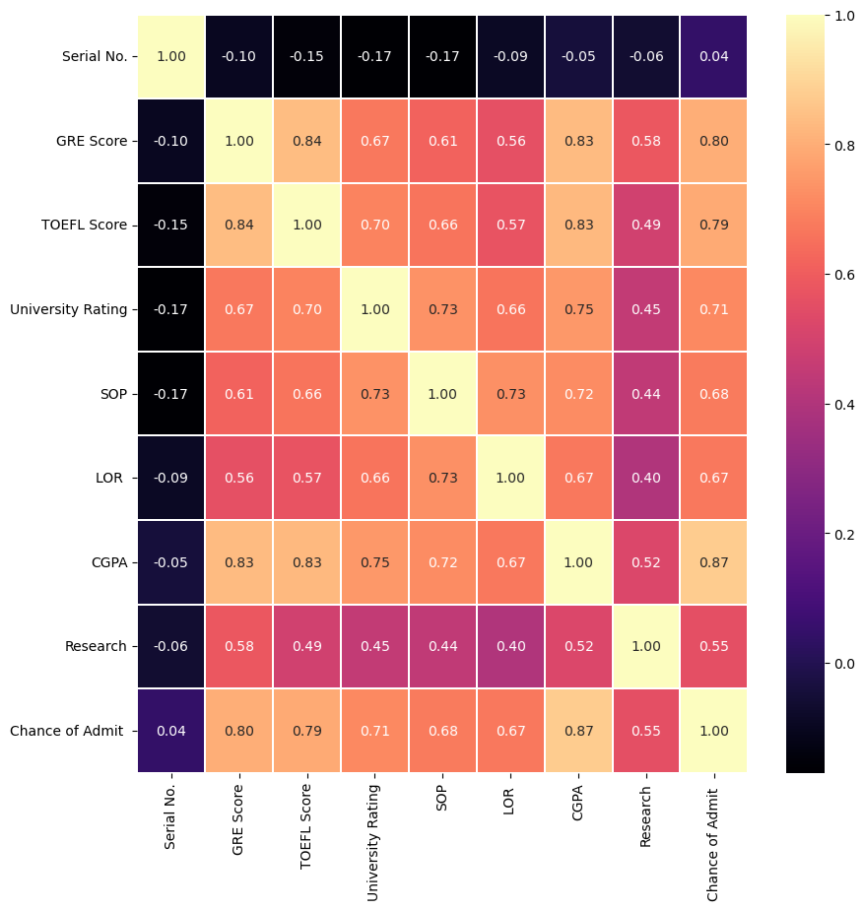

In [19]:

admission**.**Research**.**value_counts()

sns**.**countplot(x**=**"University Rating",data**=**admission)

Out[19]:

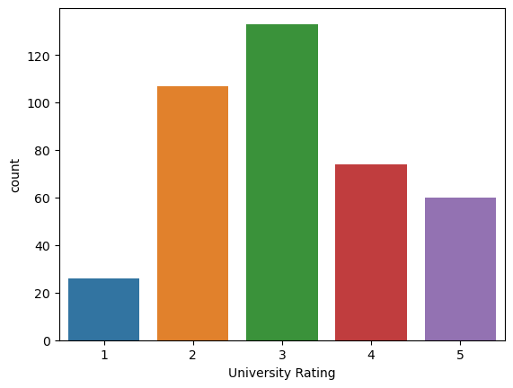

In [20]:

admission**.**Research**.**value_counts()

sns**.**countplot(x**=**"University Rating",data**=**admission)

Out[20]:



In [21]:

sns**.**barplot(x**=**"University Rating", y**=**"Chance of Admit ", data**=**admission)

Out[21]:

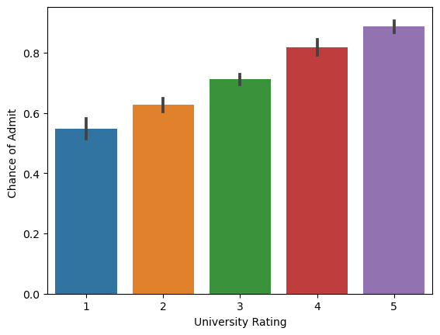

### 5. Train Test splitting.

In [22]:

*#splittin the input data(x) and output labels(y) into train data and test data*

**from** sklearn.model_selection **import** train_test_split

X_train,X_test,y_train,y_test**=**train_test_split(X,y,test_size**=**0.2) *# test_size defins the volume of train data and test data here 0.2 means 20% of the data belongs to the test data*

In [23]:

X_train**.**shape

Out[23]:

(320, 7)

In [24]:

X_test**.**shape

Out[24]:

(80, 7)

### 6. Data Preprocessing.

In [25]:

**from** sklearn.preprocessing **import** MinMaxScaler

scaler**=**MinMaxScaler()

X_train[X_train**.**columns] **=** scaler**.**fit_transform(X_train[X_train**.**columns]**.**values)

X_test[X_test**.**columns] **=** scaler**.**transform(X_test[X_test**.**columns]**.**values)

X_train**.**head()

|  | **GRE Score** | **TOEFL Score** | **University Rating** | **SOP** | **LOR** |  | **CGPA** | **Research** |
| --- | --- | --- | --- | --- | --- | --- | --- | --- |
| **373** | 0.586957 | 0.607143 | 0.50 | 0.500 | 0.500 |  | 0.492647 | 1.0 |
| **22** | 0.739130 | 0.857143 | 1.00 | 1.000 | 1.000 |  | 0.845588 | 1.0 |
| **387** | 0.282609 | 0.464286 | 0.25 | 0.250 | 0.625 |  | 0.330882 | 0.0 |
| **123** | 0.304348 | 0.571429 | 0.50 | 0.625 | 0.625 |  | 0.375000 | 0.0 |
| **110** | 0.239130 | 0.571429 | 1.00 | 0.500 | 0.500 |  | 0.470588 | 0.0 |

### 7. Selecting the ML model.

In [26]:

**from** sklearn.ensemble **import** RandomForestRegressor

rgr**=**RandomForestRegressor()

rgr**.**fit(X_train,y_train)

y_pred **=** rgr**.**predict(X_test)

print(y_pred)

[0.6517 0.6546 0.8602 0.9525 0.6206 0.7594 0.4461 0.8767 0.4899 0.9091

0.432 0.6999 0.6504 0.8401 0.905 0.6321 0.8477 0.9277 0.6197 0.8839

0.624 0.6407 0.6075 0.7921 0.8011 0.931 0.9394 0.7331 0.6757 0.5925

0.6439 0.6573 0.6809 0.9414 0.7547 0.7148 0.655 0.6797 0.7562 0.73

0.4789 0.9497 0.595 0.51 0.6656 0.9393 0.6864 0.8237 0.6649 0.742

0.7438 0.7957 0.5085 0.6033 0.9226 0.8274 0.7199 0.9141 0.9172 0.5949

0.705 0.8919 0.6536 0.6315 0.6823 0.7893 0.8459 0.513 0.7773 0.54

0.6304 0.513 0.5502 0.9548 0.6373 0.6817 0.6574 0.8482 0.6992 0.4573]

In [27]:

y_test

Out[27]:

342 0.58

62 0.54

190 0.90

130 0.96

224 0.67

...

280 0.68

247 0.71

12 0.78

252 0.71

79 0.46

Name: Chance of Admit , Length: 80, dtype: float64

In [28]:

rgr**.**score(X_test,y_test)

Out[28]:

0.820153259924319

### 8. Model Evaluation

In [29]:

**from** sklearn.metrics **import** mean_squared_error, r2_score,mean_absolute_error,roc_auc_score,recall_score

print('model score:',rgr**.**score(X_test,y_test))

print('Mean Absolute Error:', mean_absolute_error(y_test, y_pred))

print('Mean Squared Error:', mean_squared_error(y_test, y_pred))

print('Root Mean Squared Error:', np**.**sqrt(mean_squared_error(y_test, y_pred)))

print('roc score:',roc_auc_score(y_test**>**0.5, y_pred**>**0.5))

print('recall score:',recall_score(y_test**>**0.5, y_pred**>**0.5))

model score: 0.820153259924319

Mean Absolute Error: 0.04676374999999999

Mean Squared Error: 0.0038259696250000003

Root Mean Squared Error: 0.06185442284105479

roc score: 0.7430555555555556

recall score: 0.9861111111111112

### 9. Saving the Model.

In [30]:

**import** pickle

pickle**.**dump(rgr,open('model1.pkl','wb'))

**GitHub & Project Demo Link**

**GITHUB:** https://github.com/IBM-EPBL/IBM-Project-26103-1660014094

**Project Demo Link:** https://drive.google.com/drive/folders/16EJkLeBXtOqzBwmo6b38bwJKvHcO_AWw